**a. Implement Insert Operation in Node Js with Third Party Tool.**

**Final Outcome:**

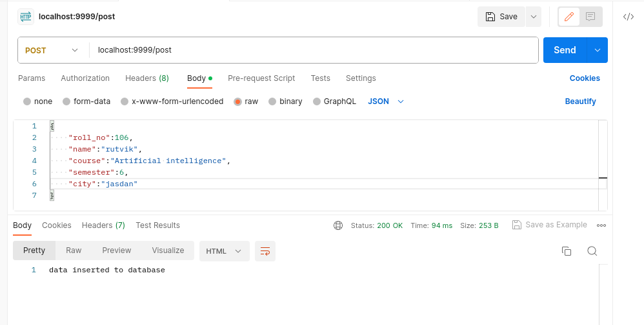

**Codesnippet:**

const mysql = require('mysql')

const express = require('express')

const app = express()

app.use(express.json())

const conn = mysql.createConnection({

host: 'localhost',

user: 'root',

password: '',

database: 'student_info'

})

conn.connect((err) => {

if (err) throw err;

else {

console.log('connection success')

app.get('/show', (req, res) => {

data = conn.query('select * from students', (err, result, fields) => {

if (err) throw err;

let jsondata = JSON.stringify(result)

res.send(jsondata)

})

})

app.post('/post', (req, res) => {

const rollNo = req.body.roll_no;

const name = req.body.name;

const course = req.body.course;

const semester = req.body.semester;

const city = req.body.city;

conn.query('insert into studentsvalues (?,?,?,?,?)',[rollNo,name,course,semester,city],(err,result)=>{

if(err) throw err;

else res.send('data inserted to database')

})

})

app.get('/show/:rollNo',(req,res)=>{

const roll_no=req.params.rollNo;

conn.query('select * from students where roll_no=?',roll_no,(err,result)=>{

if(err) throw err;

else res.send(result)

})

})

})

}})

app.listen(9999, 'localhost', () => console.log('server is running on port 9999'))

**b.Implement Update Operation in Node Js with Third Party Tool.**

**Final Outcome:**

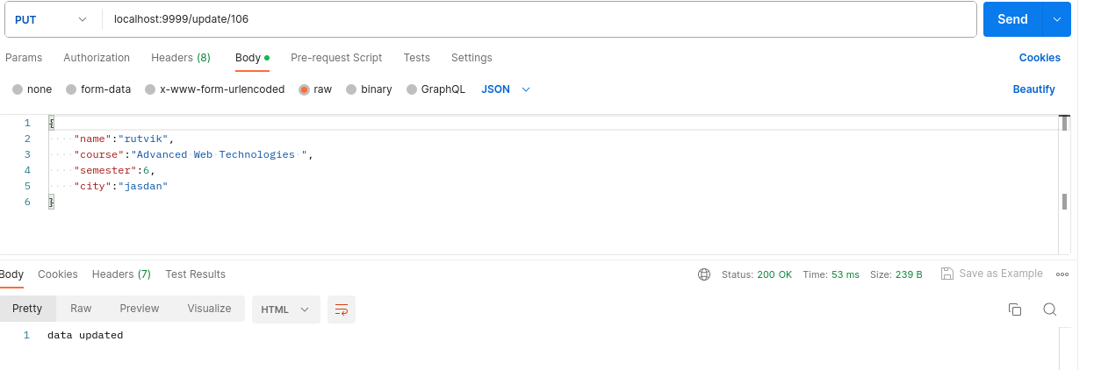

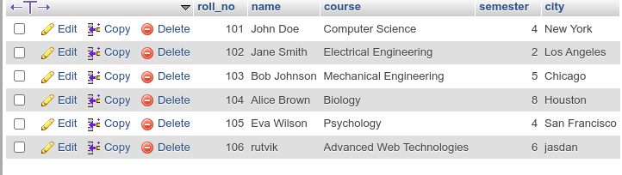

**Code snippet:**

app.put('/update/:rollNo',(req,res)=>{

const rollNo=req.params.rollNo;

const name = req.body.name;

const course = req.body.course;

const semester = req.body.semester;

const city = req.body.city;

conn.query('update students set name=?,course=?,semester=?,city=? where roll_no=?',[name,course,semester,city,rollNo],(err,result)=>{

if(err) throw err;

else{

res.send("data updated")

}

})

**c. Implement Delete Operation in Node Js with Third Party Tool**

**Final outcome:**

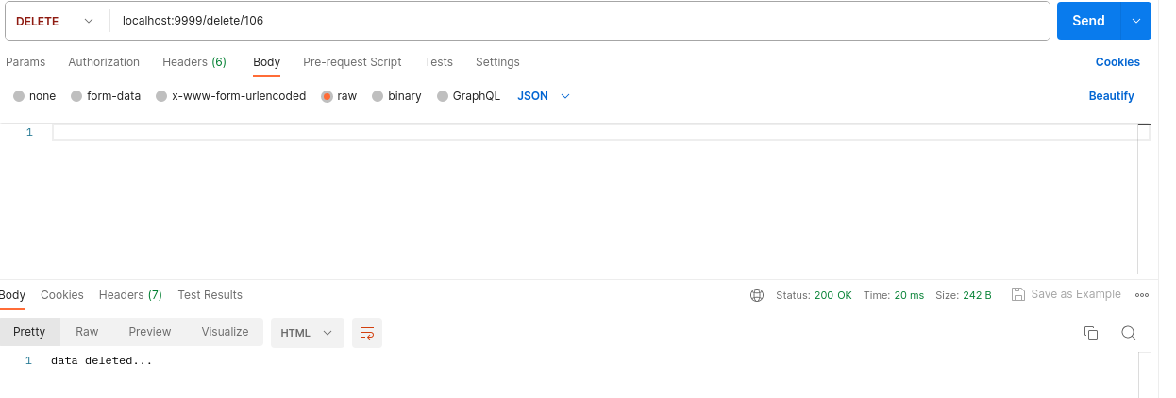

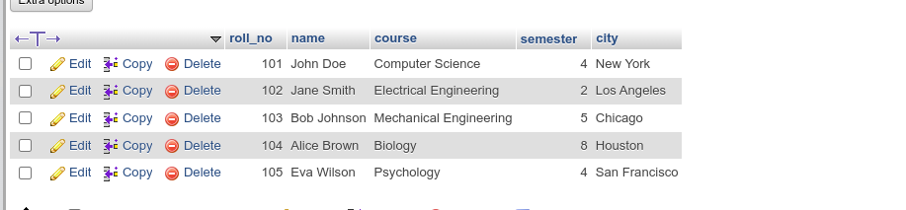

**Code snippet:**

app.delete('/delete/:rollNo',(req,res)=>{

const rollNo=req.params.rollNo;

conn.query('delete from students where roll_no=?',rollNo,(err,result)=>{

if(err) throw err;

else res.send('data deleted...')

})

})